# Accessibility of Academic Library Websites—trend and current status

# Introduction

……………..

# Literature Review

…………..

To be included in the lit review, where findings pertaining to skip nav are reported:

The absence or presence of “skip navigation” links is a crucial usability feature, particularly for people who use screen readers or navigate by keyboard only. Each time a new page loads into the browser, the screen reader will begin reading at the top, covering every link in the main, and often secondary, navigation menu. While this may be desirable for the initial visit to a site, it makes it difficult and time-consuming to get to the main content area, particular on large sites with extensive, multilevel navigation. Sighted users who cannot use a mouse face a similar problem: They must tab through every link in sequence, which may require dozens of keystrokes. While, in the WCAG guidelines, “skip navigation” is only a priority-2 error, it was incorporated into the Section-508 standards—a decision that underscores the importance of this feature.

# Purpose and Focus of this Study

As the literature review reveals, data about Web accessibility in the library world continue to give cause for concern. While, in the US, academic library web sites had become more accessible between 2002 and 2006, Bobby approval at the end of this period was still only 60%, and only 16% offered a skip-navigation feature, a Section-508 requirement. Furthermore, the close to random up and down movement with regard to accessibility suggests a lack of stability, which does not instill much confidence in our ability to predict the current situation from the 2006 data. The main purpose of this study is thus to take yet another look at the very same library websites previously investigated. This will also include a look at the use of cascading style sheets CSS and content management systems (CMS), especially the latter of which are now much more widely used, and their impact on accessibility. To keep things manageable, this study, unlike its predecessors, will only focus on academic library web sites; the web sites of schools of Library and Information Science (LIS) are beyond the range of this study.

Closely following the footsteps of its predecessors, these are the major research questions in this study:

1. In 2010 and 2012, how accessible are the library web sites of those North American campuses included in the previous studies (i.e., those campuses that have offer ALA accredited LIS programs )?

2. Has web site accessibility changed over the past five years? Is there a discernible trend?

3. If there are changes in accessibility, are there recognizable patterns associated with them?

a. How strong was the tendency for the 2006 accessibility leaders (laggards) to remain leaders (laggards) in 2010 and 2012?

b. Is there a connection between recent Web redesign and its accessibility? (Should this be deleted?)

c. Have there been changes with regard to the relative frequency of the various types of accessibility barriers?

4. Does there seem to be a connection between certain design methods/technology and accessibility?

a. How does the method of page layout (table-based or CSS-based) correlate with accessibility?

b. Does the use of a Content Management System (CMS) correlate with accessibility?

c. Does the presence of a custom search interface, e.g., a "tabbed search box" correlate with accessibility?

## Research Methodology

### Scope and Variables

### As a follow-up to the study by Comeaux and Schmetzke (2007), this investigation revisited the very same academic library Web sites included in the previous research: the library Web sites at the 56 campuses which offer ALA-accredited graduate programs in library and information studies. Of the 56 Web sites, 49 are located in the U.S. and 7 in Canada. (For a complete list, see Table XYZ).

This study involves the following variables: two metrics—percentage of Bobby-approved pages and average barriers per page—derived from Bobby-generated data; the presence of skip-navigation links (yes, no); use of CSS (yes, no); and use of a CMS (yes, no).

Bobby-generated data were collected for homepages as well as for “top-level pages”, i.e. homepages plus the subsidiary pages which are directly linked to them and which are located in the same domain. Recent data provided by Hackett and Parmanto (2008) confirm that the inclusion of the first link layer was not a bad decision: Using the more sophisticated WAB metric as an indicator of web accessibility, they found a low correlation between homepage scores and the scores of the next three link layers, but a rather strong correlation between the first link layer and the subsequent two link layers. I.e., the homepage score says little about the accessibility of the website as a whole, while the score associated with the first link layer does. Thus, including the first link layer strikes a good balance between accuracy and economy.

Information concerning skip-navigation features, CSS, and CMS were derived from the homepages and selected subsidiary pages.

### Evaluation tool and procedures

Metrics derived from Bobby-data

Two simple metrics—percentage of Bobby-approved pages and average barriers per page—were derived from the Bobby-generated raw data and used as indicators of accessibility. This choice has primarily historical reasons. Schmetzke (2001, 2002) adopted the same rough measure of the pervasiveness of barriers used by the few library and university-related accessibility studies hitherto published (such as Lilly and Van Fleet, 1999; Rowland and Smith, 1999; Flowers et al., 1999). This allowed him to compare his findings with those of these other studies. Recognizing the limitation of this indicator—it does not distinguish between pages with only one barrier and pages with multiple barriers, Comeaux and Schmetzke (2007) added a second measure that was more sensitive in this regard: the average occurrence of barriers per page. Other researchers have proposed additional metrics that also take into account the complexity of the pages investigated as well as the severity of the barriers found. (e.g., Freire *et al.,* 2008; Parmanto and Zeng, 2005; Sullivan and Matson, 2000). For the sake of consistency—the ability to compare the new data with the old one in a meaningful manner—we stuck in this study to the two indicators used in 2007.

Also for the sake of consistency, the same automated evaluation tool that had been employed in the previous rounds of data collection (2001, 2003, and 2006) was used: the downloaded version of Bobby 3.1.1. While this version of Bobby checks for compliance with the W3C guidelines (WCAG), it is only capable of checking certain features automatically. It suggests a manual evaluation for those features that it cannot check itself. This study relies exclusively on the compliance data that Bobby can automatically generate; no manual checks (other than for “skip navigation”) were performed.

Pages without any automatically detectable major (“priority 1”) accessibility problems were recorded as Bobby-approved. The priority-1 components that Bobby can automatically check are also part of the section-508 standards.

For each site, Bobby was set to check the homepage and its next layer of hyperlinked pages for accessibility errors. When the homepage was part of a frame arrangement, adjustments were made to evaluate both the individual frames as well as the pertinent pages directly linked to these frames.

With 56 web sites visited, and with an average of approximately 49 examined pages per site, a total of 2749 web pages were checked by Bobby in connection with this study. The percentage of Bobby-approved pages for each site, the accessibility of the home page, and the number and type of errors reported were assembled and analyzed in an - Excel spreadsheet.

The choice to use Bobby 3.1.1, a product that has been off the market for a number of years now, as opposed to one of the newer automated accessibility checkers, such as EvalAccess, Cynthia, AChecker, Firefox Accessibility Extension, or Functional Accessibility Evaluator, has not been easy, especially since it was rather difficult to procure a computer with an operating system that would still run this Bobby version. Why, then, was Bobby still used for this study?

Comparing the results of two accessibility checkers, Bobby and A-Prompt, Diaper and Worman (2003) observed that the latter outperformed the former with regard to Priority-1 checkpoints. A-Prompt detected almost all the problems Bobby detected in addition to some other barriers. Vigo et al. (2007) found a similar discrepancy when checking the accessibility of 1363 web pages with two more recently developed tools: LIFT and EvalAccess. (LIFT appears to be no longer available.) When these authors compared the quantitative accessibility values derived from the respective evaluation reports, they observed a marked difference between the median values (28 for LIFT versus 69 for Eval Access). As these authors explain, “[t]ools have a different coverage of guidelines in terms of quantity and accuracy.” One tool covers fewer guidelines than the other. Also, one tool performs more tests in connection with a checkpoint than the other. Clearly, for this study, which seeks to contribute to the longitudinal data already available, switching to a tool that does not measure exactly the same would be a poor decision. Bobby may not cover some of the accessibility features that newer software can check, but what it does cover should be as relevant for accessibility today as it was 10-12 years ago, when Bobby was probably the most widely used accessibility checker. Given the emphasis of this study on the trend in web accessibility, methodological consistency outweighs Bobby’s more limited coverage of accessibility checkpoints.

Skip navigation

The previous study relied heavily on the Web Accessibility Toolbar extension to identify sites using skip links. After a large number of false positives and negatives were discovered, the source code of each page was manually analyze—along with the Toolbar check.

For this study, the authors relied entirely on a manual examination of the source code to make this determination. The home page and at least one internal page, (usually the “About” page, if one could be found, or the “Services” page if no “About” page was found) was thoroughly examined. First, the terms “Skip ” and "Jump" was typed into the text search box. If either term was found, the author verified that it was indeed a skip navigation link. If neither was -found, the first screens of source code were visually examined for any internal links which may have been intended as skip links.

#### Table or CSS-based Layout

For research question 4a, the authors utilized the Web Developer toolbar, an extension developed by designer Chris Prederick (<http://chrispederick.com/work/web-developer/>). At least two pages from each site (the home page and usually the “About” page) were analyzed. First the presence of tables was tested using the “Outline > Outline Tables > Table Cells” option. This feature draws an outline around each table cell. With this view, it is fairly easy to judge whether tables are used as the primary means of layout. For example, the yellow (not green???) and blue squares in the image below show clearly how the table cells structure the page.



If using the Outline Table Cells tool did not reveal a significant presence of table cells, the “Information > Display Div Order” tool was used. This tool outlines each div element, reveals its name, and indicates its numerical order in the page code. As the image below shows, it was easy in most cases to judge if a site’s layout was primarily CSS-based.

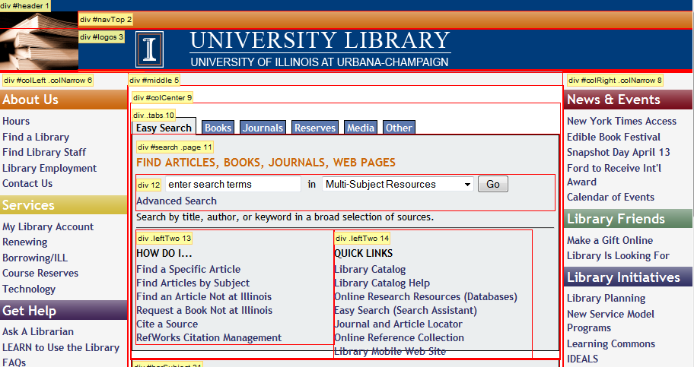

Unfortunately, not every site was as clear-cut as these two examples. Some sites use a combination of CSS and table-based layouts, and in a few cases it was difficult to determine which was the primary design element. Florida State, for example, clearly uses table-based elements as a significant aspect of page design, as shown below with Table Cells highlighted.

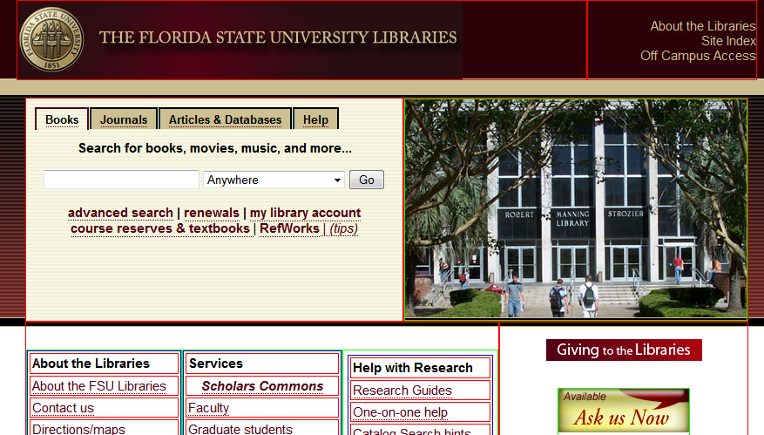

However, it also has a significant portion of its design specified with div elements, as shown in this image with Div Order highlighted.

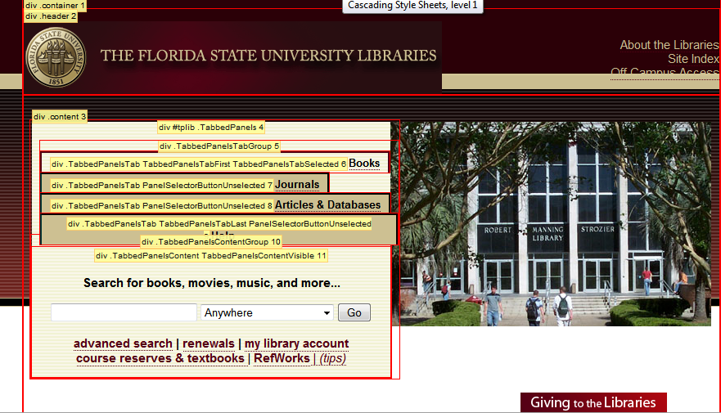

Ultimately, for this purpose of this study, the authors decided that any site that relies significantly on tables for its layout would be categorized as table-based. Therefore FSU was placed in the table-based layout group.

Site built with CMS?

In the 2010 data set, Sites were categorized as CMS or not based on a manual analysis. A CMS uses standard a code base, which results in source code with an identifiable structure. Sites employing Drupal, the most commonly used open-source Content Management system, are very easy to identify based on the application’s rigid directory structure. In other cases, the CMS was identifiable based on the "Name" Meta tag; e.g. <meta name="generator" content="Plone - http://plone.org" />. In other cases, the CMS name was visible in other areas in the page's source code.

For the 2012 study, sites were first examined using "ChromeSniffer" an extension available for the Chrome browser. This extension examines a site's source code and displays an identifying icon if a CMS is found. This tool was very effective at identifying the most popular CMS, particularly Drupal, Plone, WordPress and DotNetNuke. However, a manual examination was also performed to identify additional CMS sites.

It is very possible that more sites use CMSs than could not be readily identified. This is particularly true for "home-grown" systems, which are unlikely to leave any readily discernable source code. Because of the difficulty of proving conclusively if a site is CMS-based, the authors were conservative in this regard and chose to only categorize sites with an identifiable CMS,such as Drupal, as CMS-based.

**Statistical Methods**

Since the goal of this study is primarily to gauge certain aspects of web accessibility on the campuses with ALA-accredited library schools (all of which are included in this study), only methods of descriptive statistics are employed. (Methods of inferential statistics would be inappropriate because no sampling is involved. Since this is not a random sample of all academic libraries, generalizations from these findings to libraries on other campuses should only be considered hypotheses.)

The following statistical measures are provided: average percentage of Bobby-approved web pages per data set (all; US; Canada; tables used; CSS used; no CSM used; CMS used); range of the percentages in each set; relative frequency of specific accessibility errors; Pearson’s product-moment correlation coefficient for the connection between accessibility in 2006 and accessibility in 2011. Percentages, averages and correlation coefficients were calculated with the help of a spreadsheet (Microsoft Excel 2000) and the respective functions provided therein.

Average web site accessibility for the various data sets was calculated by first computing the percentage of Bobby-approved pages for each individual web site within the set and then taking the mean of these percentage figures. For the calculation of Spearman’s rank correlation coefficient, rank was entered as a negative number in order to accommodate the confusing fact that a numerically high rank (e.g. 23th of 24) is rendered, in everyday language, as a “low rank**.”** Thus, statements about the correlation between rank and accessibility are less likely to be mistinterpreted.(Remove if re-design is not considered.)

Percentages were rounded to the nearest whole number, averages to the nearest tenth, and correlation coefficients to the nearest hundredth.

New literature cited (to be incorporated into the Reference section; already in Harvard style)

Comeaux, D. and Schmetzke, A. (2007), “Web accessibility trends in university libraries and library schools”. *Library Hi Tech*, Vol. 25 No. 4, pp. 457-77.

[Diaper](http://www.interaction-design.org/references/authors/dan_diaper.html), Dan and [Worman](http://www.interaction-design.org/references/authors/l__worman.html), L. (2003), “Two falls out of three in the automated accessibility assessment of World Wide Web sites: A-Prompt vs. Bobby”, in *Proceedings of the HCI03 Conference on People and Computers XVII*, pp. 349-364.

Flowers, C.P., Bray, M. and Algozzine, R.F. (1999), “Accessibility of special education program home pages”, *Journal of Special Education Technology*, Vol. 14, pp. 21-6.

Freire, A.P., Fortes, R.P.M., Turine, M.A.S. and Paiva, D.M.B. (2008), “An evaluation of web accessibility metrics based on their attributes”, in *SIGDOC '08: Proceedings of the 26th Annual ACM International Conference on Design of Communication*, ACM, New York, pp. 73-80.

Hackett, S. and Parmanto, B. (2008), “Homepage not enough when evaluating web site accessibility”, *Internet Research*, Vol. 19 No. 1, pp. 78-87.

Parmanto, B. and Zeng, X. (2005), “Metric for web accessibility evaluation*”, Journal of the American Society for Information Science and Technology*, Vol. 56 No. 33, pp. 1394-1404.

Rowland, C. and Smith, T. (1999), “Web site accessibility”, *The Power of Independence*, (Outreach Division, Center for Persons with Disabilities: Utah State University), Summer Issue.

Sullivan, T., and Matson, R. (2000), “Barriers to use: usability and content accessibility on the web’s most popular sites”, in *CUU ’00: Proceedings of the 2000 Conference on Universal Usability*, ACM, New York, pp. 139-144.

Vigo, M., Arrue, M. Brajnik, G., Lormuscio, R. and Abascal, J. (2007), “Quantitative metrics for measuring accessibility”, *W4A2007 - Technical Paper, May 07–08, 2007, Banff, Canada. Co-*

*located with the 16th International World Wide Web Conference*. ACM, New York, pp. 99-107.